Precise annotation of TSS peaks uncovering complexity in state-dependent activation of transcription initiation

  - Hideya Kawaji^{1,2,3,4} and Alistair Forrest^{1,4} for the FANTOM consortium

¹RIKEN Omics Science Center, RIKEN Yokohama Institute, 1-7-22 Suehiro-cho, Tsurumi-ku, Yokohama, Kanagawa, 230-0045, Japan
²Preventive medicine and applied genomics unit, RIKEN Advanced Center for Computing and Communication, 1-7-22 Suehiro-cho, Tsurumi-ku, Yokohama, Kanagawa, 230-0045, Japan
³RIKEN Preventive Medicine and Diagnosis Innovation Program, 2-1 Hirosawa, Wako, Saitama, 351-0198, Japan
⁴Division of Genomic Technologies, RIKEN Center for Life Science Technologies, 1-7-22 Suehiro-cho, Tsurumi-ku, Yokohama, Kanagawa, 230-0045, Japan

Recent progress of technology development in high-throughput sequencing, for example CAGE (Cap Analysis Gene Expression), enabled us to identify transcription starting sites (TSSs) and quantify their activities experimentally across the genome. Given the complexity of transcription (ref: ENCODE transcriptome), empirical annotation of TSSs based on experimental data is an essential baseline to understand transcriptional regulation in individual cells, and investigate them in the transcriptome space. In the FANTOM5 project (Forrest et al. Nature 507, 462–470, 2014), we profiled TSS activities more than one thousand mammalian samples including diverse range of primary cells, to understand transcriptome states encoded in the genomes. It was a major challenge to produce TSS annotations capturing all the complexity of transcription in such heterogeneous data.
Here we developed a new method to identify TSS peaks empirically from such diverse range of TSS profiles. The method relies on estimation of underlying TSS profiles by using ICA (independent component analysis). The result successfully discriminated proximal TSSs differentially used, while the other approaches failed (Figure 1). We found that our approach defines TSS peaks precisely, that is, covering known genes extensively with a quite limited amount of genome coverage (~0.5% of the genome, Figure 2). The result was used as a baseline to assess composite promoters (Forrest et al. Nature 507, 462–470, 2014), and we additionally assessed alternative promoters of genes. We found almost a half of the genes have transcribed from by multiple TSSs differentially activated (Figure 3). Further we assessed accuracy of gene model 5’-end, to provide an overview of different gene models. The resulting data represent the most advanced baseline to understand transcription initiation to understand complexity of transcription initiation.

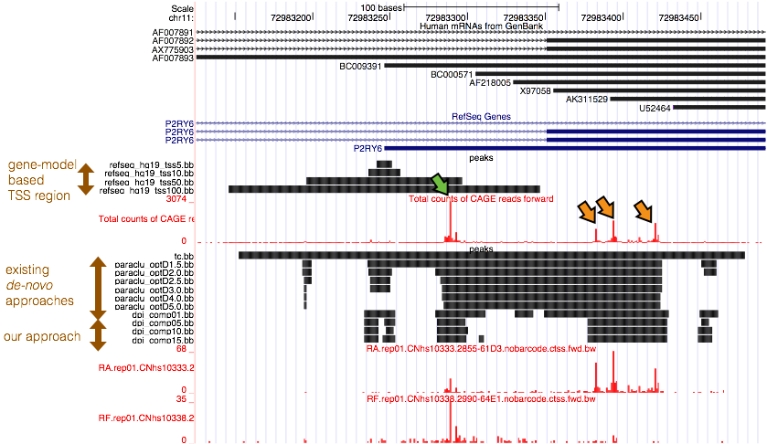
Figure 1. The peaks identified by existing our methods and existing methods. 5’-end of RefSeq gene model turned out to be imprecise. Green and orange arrows indicate differently activated TSSs between THP-1 cells and HeLa cells. Our approach successfully discriminate them, while previous approaches failed

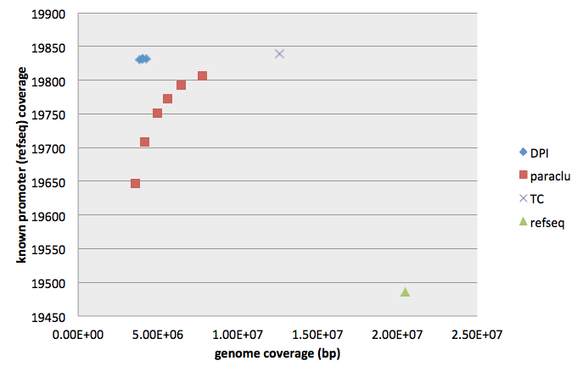
Figure 2. The coverage of genomic region and the known genes by different approaches. X axis indicates genome coverage, that is, the total length of the peaks across the genome. Y axis indicates the number of genes found. DPI represent our approach with several parameters. Paraclu is the method published before (Frith et al. Genome Res. 18, 1-12, 2008), TC represent tag clustering (Carninci et al. Nature Genetics 38, 626-635, 2006), and refseq indicates +/-500bp region from the 5’-end of refseq gene models. The result underline that our approach cover nearly the largest number of genes with a smaller coverage of the genome.

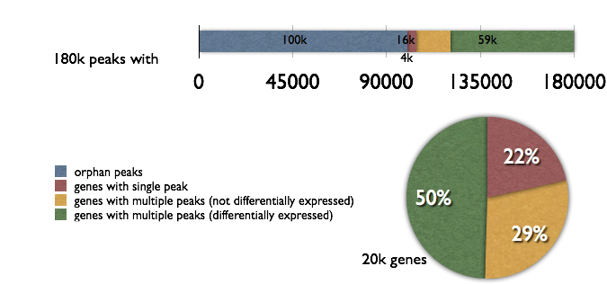
Figure 3. Genes with TSS peaks under different regulation.

