Coexpression anlaysis and pathway annotation
We applied established coexpression analysis methods¹ to group promoters that share similar expression profiles across all samples, enabling additional insights into the biology of annotated genes, and inferences about the possible role of the 90,000[x] TSS clusters whose function is not apparent from genomic location alone.
124,090 promoters were allocated to 4882 coexpression groups with Pearson r > 0.75 and MCLi = 2.2 (Figure JKB_1, see Supplementary Methods). In order to evaluate and annotate these coexpressed groups, we tested for enrichment in a curated database of 633 biological pathways [ref])(including 227 KEGG pathways²). Of these, 500 pathways (195 KEGG) were significantly enriched in at least one coexpression group (FDR<0.05).
Among these, the KEGG pathway for influenza A pathogenesis (hsa:05164) is strikingly over-represented in one small coexpression group in particular (C413, FDR=2x10⁻¹¹). Of 19 promoters in this coexpression group, 8 are present in the KEGG pathway, including RIG-I (DDX58), the canonical receptor for mitochondrial antiviral signalling³(Supplementary Figure JKB_S1). The remaining 11 promoters include some compelling candidates for involvement in the host response to influenza: 4 of these genes (TRIM21, TRIM22, RTP4, and XAF1) were found to be key host determinants of influenza virus replication in a single high-throughput siRNA screen (616 genes reported in total)⁴. Another gene, PLSCR1, is required for a normal interferon response to influenza A⁵.
A particular advantage of CAGE is that alternative TSS for the same protein-coding gene with divergent expression profiles may occupy different positions in the coexpression network. For example, in coexpression group C413 an inducible variant of IRF9 is tightly associated with other transcripts implicated in influenza pathogenesis, but a more abundant constitutively-expressed transcript 403bp upstream is coexpressed with a different group of genes (group 26) (Supplementary Figure [IRF9_differential_expression_profiles.png]). Although the inducible transcript may give rise to a truncated 5’UTR, it is not clear that it serves a different biological function. However the differential regulation of these transcripts does improve the power of annotation by coexpression: the most abundantly-expressed TSS clusters for IRF7, DDX58, and IRF9 are widely separated in the coexpression network, and so the compelling association between them would not have been detected with other methods.
[Species conservation of IRF9 alternative promoter?]
This influenza host response signature is of particular interest, since among the 886 samples in the expression profiles described here there are no samples that were deliberately exposed to influenza virus. The detection of strongly enriched clusters for response to influenza therefore demonstrates the general principle that coexpression signatures for a range of biological processes can be extrapolated from a sufficiently diverse atlas of gene expression.

References
1. Hume, D. A., Summers, K. M., Raza, S., Baillie, J. K. & Freeman, T. C. Functional clustering and lineage markers: insights into cellular differentiation and gene function from large-scale microarray studies of purified primary cell populations. Genomics 95, 328–338 (2010).
2. Kanehisa, M. & Goto, S. KEGG: kyoto encyclopedia of genes and genomes. Nucleic Acids Res 28, 27–30 (2000).
3. Yoneyama, M. et al. The RNA helicase RIG-I has an essential function in double-stranded RNA-induced innate antiviral responses. Nature Immunology 5, 730–737 (2004).
4. Shapira, S. D. et al. A Physical and Regulatory Map of Host-Influenza Interactions Reveals Pathways in H1N1 Infection. Cell 139, 1255–1267 (2009).
5. Talukder, A. H. et al. Phospholipid Scramblase 1 regulates Toll-like receptor 9-mediated type I interferon production in plasmacytoid dendritic cells. Cell Research 22, 1129–1139 (2012).

Figures.
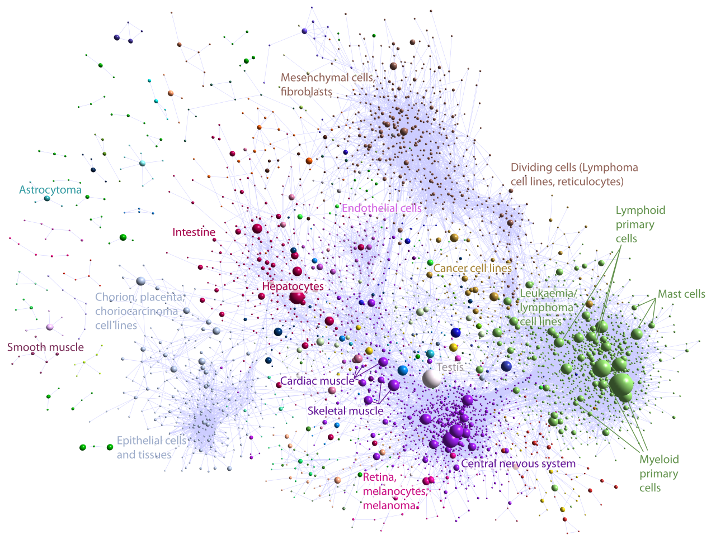
[OPTION 1]
[OPTION 2]
Figure JKB_1 [f5_coexpression_A.png OR f5_coexpression_all_pathways.tif]. Collapsed coexpression network showing 4664 coexpression groups (one node is one group of promoters) derived from expression profiles of 182,000 promoters across 887 primary cell types, tissues and cell lines (r>0.75, MCLi=2.2). For display, each group of promoters is collapsed into a sphere, the radius of which is proportional to the cube root of the number of promoters in that group. Edges indicate r>0.6 between the average expression profiles of each cluster. Colours indicate loosely-associated collections of coexpression groups (MCLi=1.2).
Labels show representative descriptions of the dominant cell type in coexpression groups in each region of the network, and a selection of highly-enriched pathways (FDR<10-4) from KEGG (K), WikiPathways (W), Netpath (N) and Reactome (R).

Supplementary Figure JKB_S1 [F5_flu_pathway_FLU.tif]. Overlay of coexpression groups enriched for genes involved in the KEGG pathway for influenza A pathogenesis (hsa:05164; FDR<0.1, n>2). (a) Collapsed coexpression network showing 5 groups enriched for influenza pathogenesis genes: C0 (blue), C26 (purple), C61 (yellow), C187 (green) and C413 (red). (b) Excerpt from KEGG pathway diagram showing positions of genes in each coexpression group (background colours as in (a)). Pathway entities that map to two coexpression groups have the background colour of the smaller group, and the text/border colour of the larger group. Details and promoter-level displays (edges indicate r>0.75) for two coexpression groups are displayed with transcripts mapping to KEGG pathway highlighted (inset).
[KEGG pathway is pixelated – I could fix this by manually drawing over it but probably not necessary for a supplementary figure. I’ll do this if it is considered a possibility for a main figure!]

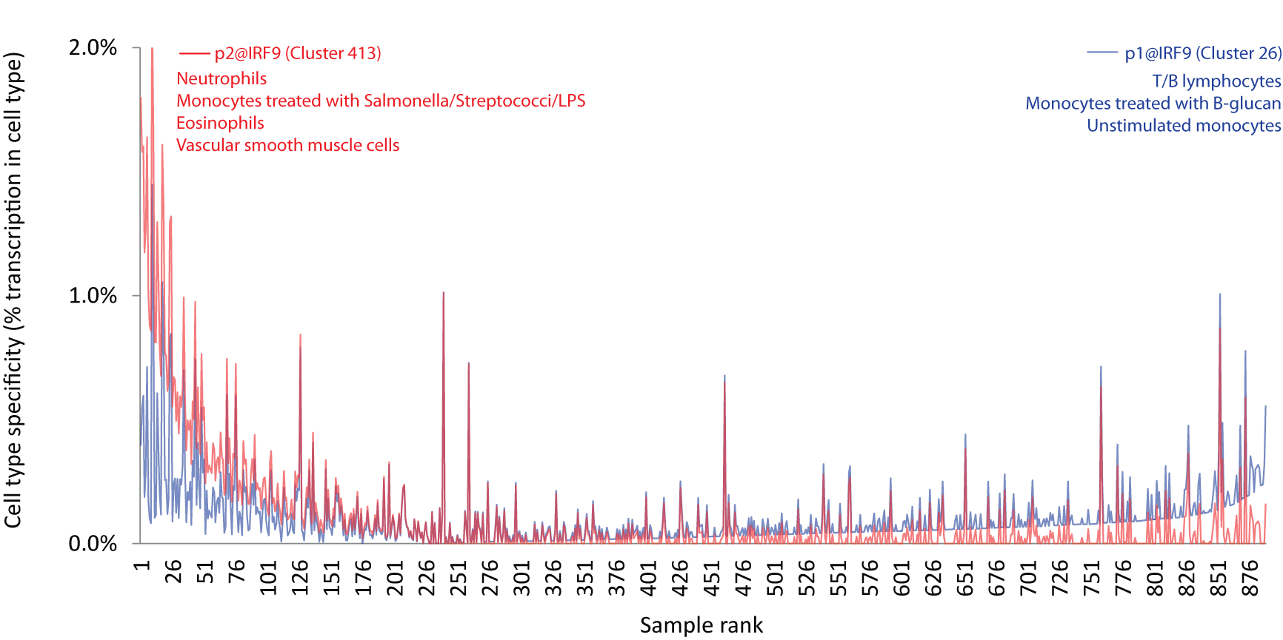
Supplementary Figure JKB_S2 [IRF9_differential_expression_profiles.png]. Differential expression specificity of two promoters of IRF9. Expression is shown in all samples sorted by difference in specificity. Less abundant transcription initiating at a second promoter (p2@IRF9) is inducible in some cell types, in contrast to the more constitutive expression pattern of the dominant transcript (p1@IRF9).
[NOTE – could we add a high-res image of the TSS for IRF9 from zenbu?]

